Name: | ___________________________________________________ | Date: ___________
 | Year 10 Mathematics – Trigonometry test  Test 7, 2021  Topic – Trigonometry | 32  = %

Question 1 (8 marks)
(a) Show use of trigonometry to determine the length of side $BC$ in the triangle below, where $∠BAC=122°, AB=58 \text{cm}$ and $AC=71 \text{cm}$. (2 marks)

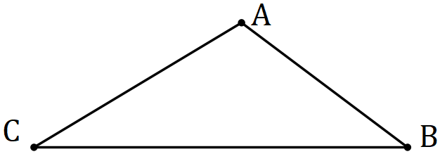

(b) Show use of trigonometry to determine the size of angle $∠PRQ$ in the triangle below, where $∠QPR=105°, PR=45 \text{cm}$ and $QR=65 \text{cm}$. (3 marks)

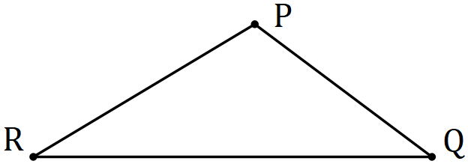

(c) Find the area of the triangle below (3 marks)
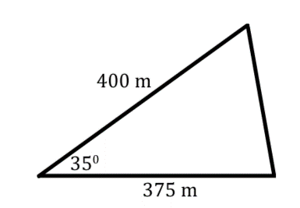

Question 2 (5 marks)
(a) Draw both the Cosine and Sin wave on the half cartesian plane below (3 marks)
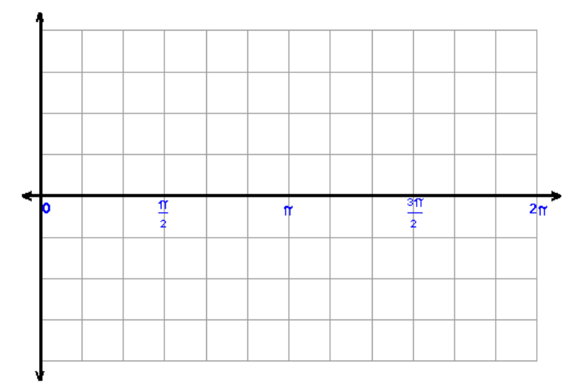

(b) What is significant about the 2π (2 marks)

Question 3 (4 marks)
(a) Determine amplitude and period of the graph below (2 marks)

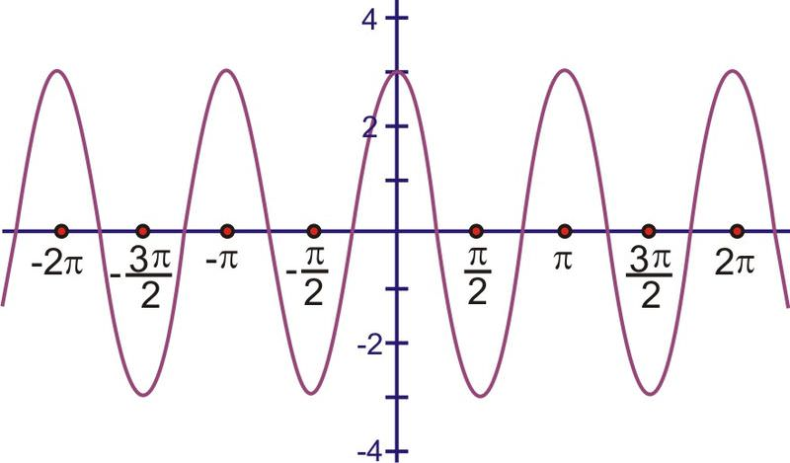

(b) What is the equation of the graph? (2 marks)

Question 3 (15 marks)

(b) Complete the exact values table below (6 marks)
 | sin | cos | tan
0° |  | 1
___/$\frac{π}{6}$ | $$\frac{1}{2}$$
60°/___ |  |  | $$\sqrt{3}$$
___°/$\frac{π}{2}$ |  | 0 | Undefined
___°/$\frac{π}{4}$ | $$\frac{\sqrt{2}}{2}$$ |  | 1

(b) On the unit circle below draw and label the coordinates of $\frac{π}{6}$ (3 marks)

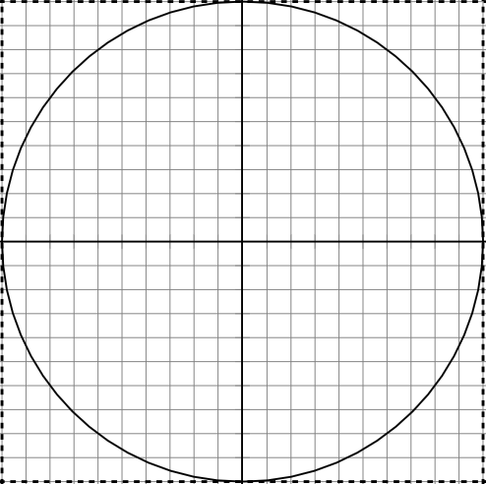

(b) Draw the matching angle of magnitude at $\frac{π}{6}$ in quadrant 2 (1 marks)

(c) What are the equivalent angles of sin(40) (3 marks)

(d) What does angles of magnitude mean? (2 marks)

